Newsletter No 32 Spring 2018 Hertfordshire Record Society
Chairman: Dr Alan Thomson Secretary: Dr Heather Falvey Treasurer: Mr Ian Fisher

Chairman's Report
Over the last 33 years the HRS has revealed, through its publications, to members and to the general public, some fascinating aspects of the history of Hertfordshire as well as national history from medieval to modern times. In the first volume, the churchwardens’ accounts of 5 local parishes were transcribed. Those from Baldock revealed the practices in the late Henrician church and the impact of the Reformation under Edward VI. Those for St Peters, St Albans illustrated the development of that Reformation in the late Elizabethan period. The edition of the Bishops Stortford Churchwardens’ Accounts went further back to 1431 and revealed the practices in the local church before the Elizabethan Reformation. The volume on religion in the county during the mid-19th century transcribed the Upton Survey of 1847-8 and the Ecclesiastical Census of 1851 showed how various forms of Protestantism had developed alongside the Anglican establishment.

Different aspects of local society over time have been shown in a number of volumes including The Records of the Manor of Norton 1244-1539, which identified a number of aspects of the operations of the late medieval Feudal System. Early Stuart Household Accounts, showed the lifestyles of the aristocratic Cecils at Hatfield and the Earls of Sussex at Gorhambury in the 1630s. Hertford Wills and Inventories illustrated the very different lifestyle of townsmen and women, craftsmen, widows and others of the ‘middling sort’ in the later 17th and early 18th century. This will be joined soon by a similar volume from St Albans for the earlier 17th century. Such volumes show the changes taking place in local society in both rural and urban areas from the medieval to the early modern period.

Other aspects of religious and social affairs have been revealed in a number of volumes including the Layston Parish Memorandum Book for the 17th and 18th century, the Datchworth Tithe Accounts for the early 18th century, and Carrington’s Diary Volume 1, soon to be joined by Volume II, and the Diary of Benjamin Woodcock. These show how the local parishes coped with a variety of issues and financial problems, including raising money for the poor and for the church, how the poor were treated and the New Poor Law operated and how the farmer John Carrington revealed in his diary many aspects of local society, including modes of travel, gossip, life and death.

Other local and national military affairs over the centuries have been examined in three volumes: the Muster Books for North & East Hertfordshire 1580-1605; the Impact of the First Civil War on Hertfordshire; and Julian Grenfell, Soldier and Poet, Letters and Diaries 1910-15. Many of the above volumes contain details of prices, fees and local finances indicating the wealth of the county. The earliest volume so far on taxation is Hertfordshire Lay Subsidy Rolls

1307 and 1334, which shows the assessment across the county for national purposes, as does my volume for the various armies that Hertfordshire had to pay for in the 17th century.

Apart from Grenfell and Woodcock’s diaries, two volumes of 19th century diaries have also been published: transcriptions of those of Henry Lomas and Thomas Newcome, and The Diary of Lady Capel of Cassiobury, 1841-1842. These were a plumber, a rector and an aristocratic teenager, all from the west side of the county. These all give an insight into the personal and public lives of people from a variety of walks of life and show the gradual changes taking place across the county. Rather different insights into an individual’s personal interests are found in 3 volumes, Sir John Wittewrong’s Weather Diary 1684-1689, Lord Fordwich’s Grand Tour 1756-60 and Baroness Dimsdale’s receipt book c.1800. The first shows that nectarines were grown in Harpenden, the second that a local Aristocrat who fell in love with Italy did not return home, and the third that doughnuts may have originated in the county.

Letters as well as diaries also give us an insight into the views of historical individuals, something that is likely to be lost as electronic replaces written communication. We look forward this year to meeting in the historic Hatfield House, whose owners influenced national life in both the 16-17th century and again in the 19th. We hope soon to publish an account of an attempt by Walter Morrell to establish a plan for “New Draperies” at Hatfield, St Albans and Berkhamsted, a project sponsored by Robert Cecil, first earl of Salisbury. The Society has aimed to publish a wide variety of sources, on a broad range of subjects from the medieval to modern times and to try and link the local to the national. We hope to continue this and would always welcome any new proposal that can be published.
Alan Thomson

AGM Venue: The Van Dyck Room at Hatfield House
The Van Dyck Room is situated on the ground floor of the East Wing, the part of Hatfield House that has always been reserved for the more private occupation of the owners. The rooms above it, on the first floor, were set aside for use by the King and have a view over the most ornamental part of the gardens.

Robert Cecil, 1st Earl of Salisbury, who built Hatfield House between 1607 and 1612, intended the room to be his book chamber. However it has generally been used as a dining room by later generations of the family. The room still retains an important original fireplace, carved to depict two sets of the Four Elements. It is one of three chimneypieces supplied to the House by Maximilian Colt, Master Sculptor to King James I. (Colt was also responsible for Robert Cecil’s tomb in Hatfield parish church.)
The room’s present appearance owes much to the 2nd Marquess of Salisbury (1791–1868) who installed panelling of birch and cherry wood in the 1830s. The Jacobean-style plaster ceiling dates from the same period.

A number of fine, mostly seventeenth century, family portraits hang in the room. Several are by Sir Peter Lely and Sir Godfrey Kneller. Two others, of the 4th Earl of Pembroke by Daniel Mytens and of the 10th Earl of Northumberland and his wife and family, are outstanding. The latter exists in several versions, at Petworth, Gorhambury and elsewhere. The Hatfield version was long thought to be the original by Sir Anthony Van Dyck and the room was named after it. Unfortunately the picture was somewhat demoted in the 1971 catalogue of Paintings & Sculpture at Hatfield House and it is now held to be a product of the Studio of Sir Anthony Van Dyck.
Robin Harcourt Williams

Photographs from the visit to St Leonard’s Church, Bengeo, after the 2017 AGM
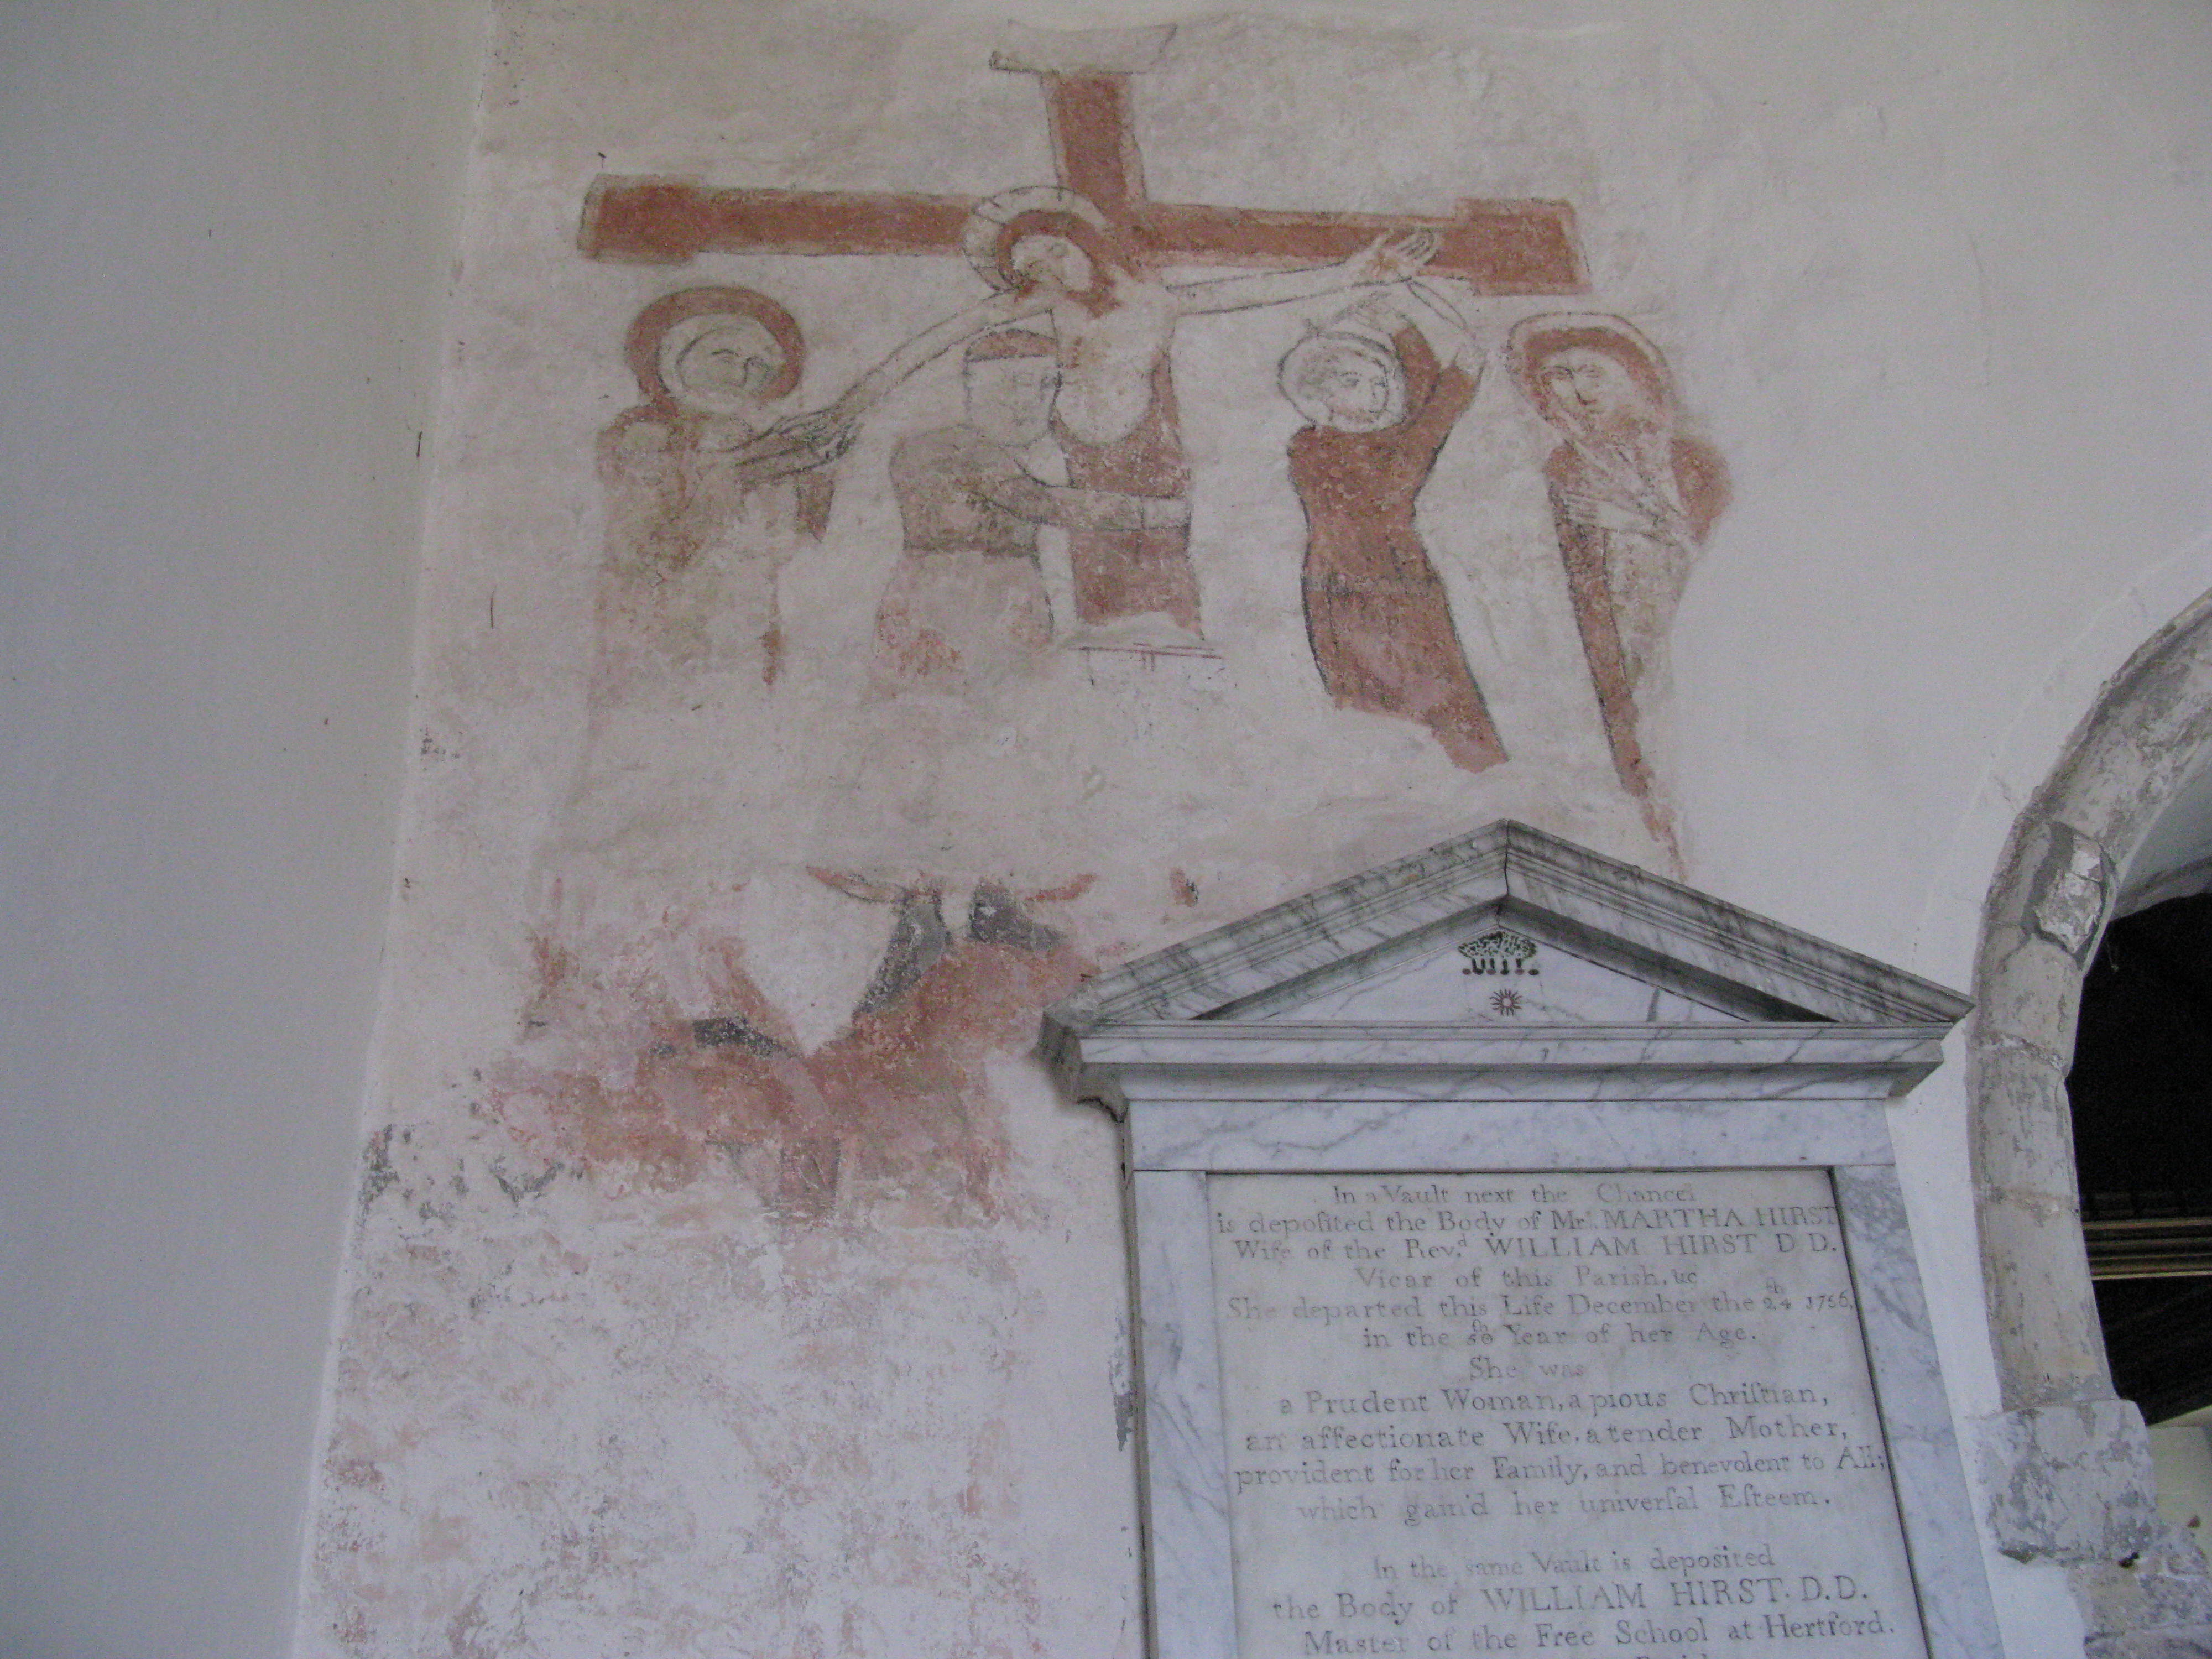
The wall paintings are believed to date from the 13th century.

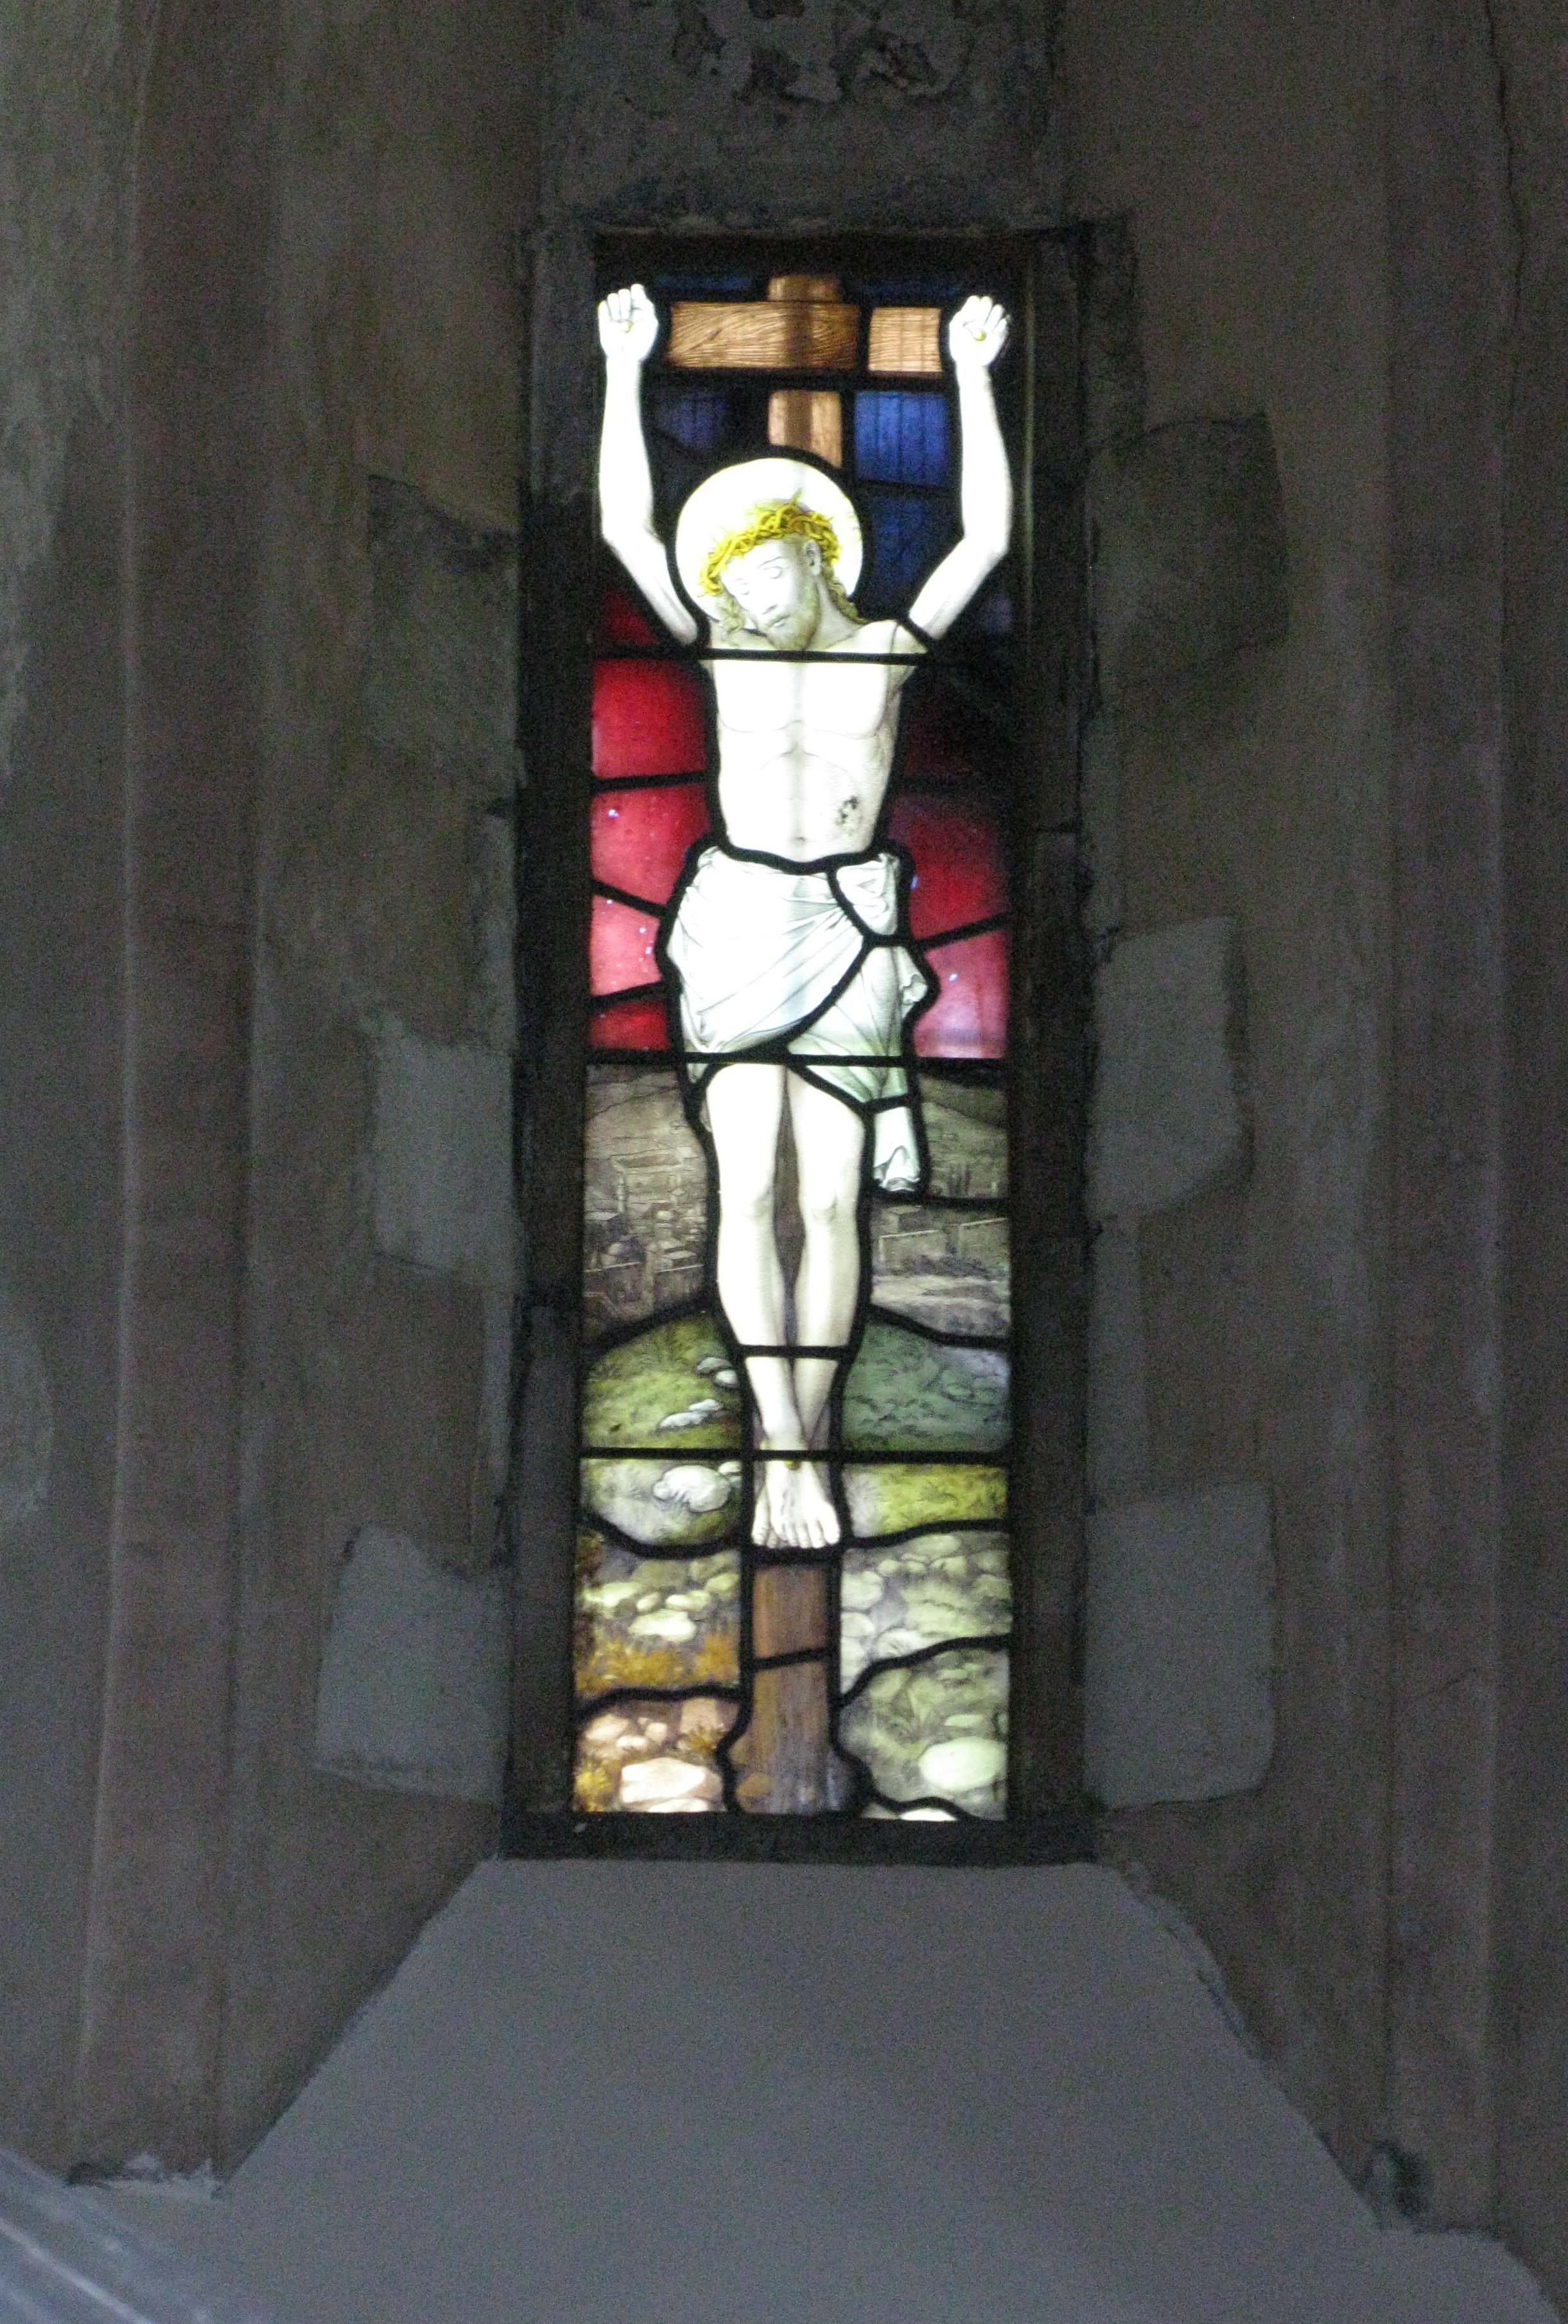
Victorian stained glass in a 15th century window

Volume XXXII, Wills, inventories and probate accounts from St Albans, 1600-1615: a comparison with Birmingham
We are hoping that Volume XXXII, Wills, inventories and probate accounts from St Albans, 1600-1615, the volume for the membership year 2016/17, will be published during 2018/19. The number of documents transcribed and sheer volume of detail within those documents have meant that it has taken longer to complete the text than originally anticipated. Pat Howe and Jane Harris have been working hard on the Introduction which analyses the contents of the documents and what they tell us about early seventeenth century St Albans. As reported in the 2016 HRS Newsletter, the testators from this important urban centre include many craftsmen and tradesmen, but there are also gentlemen, yeomen, husbandmen and widows. The values of their probate inventories vary widely, indicating great contrasts in wealth at the time of death.

With regard to the craftsmen and tradesmen, ‘shops’ occur in 34 of the inventories. It is not always clear whether this was a retail shop or a workshop that was being appraised; indeed it is likely that some were used for both purposes. As Pat Howe notes in the Introduction ‘The idea of shops for retail puts a face on the streets and alleyways of the town centre’. Two chandlers, John Lawrence and Edward Moseley, and one grocer, Nicholas Poole, had retail shops: these two types of trader appear to have dealt in similar wares, selling a wide range of goods from chapbooks to candles, groceries to household utensils. Other shopkeepers include Richard Bull, bottle maker; Thomas Goodes, glover; Robert Woolley, draper; and two tailors, William Prior and John Thompson. John Hodgkinson, a coverlet weaver, had a shop which accommodated the large loom required by his trade; it is unlikely that his customers would have had access to this particular shop. There are six shoemakers with inventories: Thomas Camfeild, Walter Dewbury, Hugh Gilbert, Tobias Gorste, John Moncke and Ralph Savage. Four of these men had ‘shops’ recorded in their inventories, all of which are very likely to have been used for making boots and shoes as well as selling them. Of these shoemakers, Thomas Camfeild’s inventory is noteworthy because it gives very full details of his stock. (HALS: A25/2257). He had over 100 pairs of shoes and 8 pairs of boots on the shelves of his shop, most of which are sized. The method of shoe sizing he used appears to be the same as we use today, with children’s sizes going up to 13. The other shoemakers did not have so many shoes in stock but Tobias Gorste had seven dozen lasts, indicating that a large number of different sizes could be made. (HALS: A25/2164)

I have recently reviewed for the Economic History Review Jacqueline Geater’s edition of sixteenth century wills and inventories from Birmingham. (Birmingham Wills and Inventories, 1512-1603 (Stratford-upon-Avon: The Dugdale Society, 2016). The first thing that struck me about this collection was the paucity of wills and inventories from this important growing industrial town. There are only 156 sets of probate documents, relating to 139 men and 17 women who lived (or rather died) in the Birmingham area during the sixteenth century; nor are there any medieval Birmingham wills. A brief investigation of my own revealed that this very low rate of document survival is because there are no probate registers from the diocese of Coventry and Lichfield, only original documents. It seems that probate registers were never maintained in that diocese, it is not simply that they have not survived the ravages of time. This brought home to me how lucky we are in south-west Hertfordshire to have the probate registers of the Archdeaconry of St Albans which commence in 1415. (Crawley et al., Wills at Hertford (2007), p.x) Nevertheless, the Birmingham inventories include five relating to cordwainers, or shoemakers, four of which were made towards the end of the century and so are analogous with the St Albans inventories. However, the detailed record of shoe stocks given in the inventory of Thomas Camfeild of St Albans contrasts dramatically with the lack of detail in the Birmingham shoemakers’ inventories. Indeed, Humfrey Lowe (d. early 1540) had bequeathed to his servant Nicholas Banner ‘all my knyves and lasts and lykre Tubbes [liquid for treating leather] belonging to my occupatyon’ (Birmingham Wills, p.68); consequently his inventory simply recorded ‘In the Shoppe: All thynges gyffen & bequethid by the seid Humffrey Lowe to his servand’ (p.69). Three of the other Birmingham inventories actually mention a stock of shoes, but only in terms of total numbers: ‘11 dossen of showes lacking 1 paire’ (Thomas Groves, 1586; p.275); ‘five dossen of shewes’ (Thomas Coxe, 1592; p.327); and ‘seaven dossen of Showes’ (Richard Neale, c.1597; p.361). On the other hand, the prices of Thomas Camfeild’s sized shoes can be calculated from his inventory valuations: for example, ‘eleven payre of two sole shoes of the sixes’ are valued at 16s 6d, giving the cost of one pair as 1s 6d. Contained in the debts of Hugh Gilbert is an entry noting that Everard Wright owed 20d for a pair of shoes for ‘his kinsman who is lame in his back’. (HALS: A25/2101).

Given the details included in these inventories, the St Albans volume will be of interest to historians of various aspect of early modern life, as well as to local historians of Hertfordshire. We look forward to its publication.
Heather Falvey

Review of the Barnet Enclosure Award Maps and Schedule, published in The Local Historian, 48 (2018), pp.78-79. [part of a longer review article on various published maps]
Some 5,000 Acts concerned with enclosure were passed between the 1720s and 1900, covering perhaps one-fifth of the area of England. The commissioners who surveyed the unenclosed land and parcelled it out into new allotments brought about a dramatic remodelling of the landscape. It is worth remembering, though, that the maps which were generally produced to accompany their schedules depict, to an even greater extent than the Fens map, a landscape which did not actually exist at the moment when the maps were made, but which came into existence as a result of their work. Hence these maps are an essential starting point for anyone interested in the landscape or local history of a place, as they allow the reconstruction of that locality before and after its enclosure. While thousands of these manuscript maps survive in record offices, full size reproductions are relatively rare. The Hertfordshire Record Society is thus to be congratulated on publishing this reproduction, especially at a very modest price.

The work comprises a folder into which are slotted full-size paper copies of the five maps which accompanied the Barnet award, together with a brief introduction by Susan Flood and a summary of the schedule by Jane Walker, listing the names, acreages and tenure of some 938 parcels. The introduction briefly describes the background to the award, but it is to be regretted that this is so brief. Enclosure maps are often huge, so why was this one divided by its maker into five separate maps? Such maps generally only show the land to be enclosed, but this one surveys in detail some 687 ‘old inclosures’, buildings, gardens and the like which were not part of the award. Indeed, three of the five maps show no enclosures at all. It almost certainly follows that these maps were not made solely for the purpose of the award, but were part of a manorial survey carried out in 1817, to which Susan Flood refers. Perhaps some discussion was needed concerning the ‘old’ landscape of irregular fields; the newer landscape of large fields around the common, allotted to the Barnet Poor Trustees which emerged from the earlier 1728 enclosures; and the newly designed 1818 landscape, which included some larger fields but also a large number of very small strips of half an acre or so, both around the common and, perhaps more intriguingly, running up either side of Wood Street, greatly narrowing what had been a wide, funnel-shaped road (possibly a market), in the process creating the extensive front gardens that can now be seen on Google Earth.
Bill Shannon

Volume XXXIV, Walter Morrell’s ‘Manufacture for the New Draperie’ (1616), edited and with an Introduction by Michael Zell and Heather Falvey
This year’s volume, which will be launched at the AGM, is the text of an early seventeenth century project to set on work the unemployed poor in Hertfordshire, the original of which is held in the Huntington Library, San Marino, California. In explaining how the poor might be employed in the various processes involved in making woollen cloth, the projector almost inadvertently sheds a great deal of light on the textile industry in early modern England.

Early in the reign of James I, Walter Morrell arrived in Hatfield with a wonderful scheme that promised to transform the lives of England’s idle poor. He needed to convince Robert Cecil, 1st Earl of Salisbury, that he could train unemployed youths to make ‘new draperies’ – a range of woollen textiles – thereby supporting themselves and also reducing the cost of poor relief. ‘Setting the poor on work’ had been a theme of English social policy since the 1570s. ‘Projects’ to do just that had been suggested before, but Morrell’s project was more convincing than most: by 1609 he had won over not only Cecil, but also most of the Privy Council. They believed that his scheme could both help to reduce rural unemployment and, by increasing textile exports to Europe, boost royal revenue.

This volume publishes the complete text of Morrell’s 100-page explanation of his project, written to coincide with the award of a royal charter establishing a monopoly new draperies company for Hertfordshire, in early 1617. Morrell’s Manufacture is a fascinating mixture of detailed economic calculation and social argument, combined with the remarkable story of its author’s persistence and zeal to ‘improve’ the English commonwealth. His text includes copies of letters and petitions that demonstrate how he had fought to win over the king’s advisors. But he still had to convince Hertfordshire’s gentry to invest in the project, for without ‘adventurers’, the Company would have no capital.

The volume includes an appendix of original documents covering the period leading up to the charter’s grant in 1617, and extending into the following decade. They illuminate Morrell’s activities before the charter was granted; attempts to extend his scheme to several towns beyond Hatfield; and the sceptical reaction of the majority of the county’s magistrates and landowners. Two detailed introductory chapters discuss Morrell, his project and his book, and efforts to establish new drapery production in other Hertfordshire towns.
To illustrate the book’s jacket we have been fortunate to obtain a photograph of the painting by Cornelis Decker entitled ‘Weaver’s Workshop’, held at the Rijksmuseum, Amsterdam, and reproduced by kind permission of the Rijksmuseum. This jolly picture of a narrow-loom weaver and his associate is almost contemporary with the manuscript.

Book Review: Victor Chinnery, ‘Names for Things’: A Description of Household Stuff, Furniture and Interiors 1500-1700, edited by Jan Chinnery (Oblong, 2016), £35
The inspiration for Names for Things came from an article written in 1991 by the author, a furniture historian, entitled ‘Furniture terminology in post-medieval middle-class inventories’ in which he alluded to the notion that besides furniture, inventories contained other objects that deserved a comprehensive glossary. He devoted the next 20 years to research such a glossary. The number of county record offices, historic houses and museums that he accessed and the 17-page bibliography give credence to his attention to detail. The work covers such items as ceramics (pots, dishes, etc), glass, metalwork (fireside and cooking equipment, etc), textiles (fabrics for clothing, bedding, etc) and divers other moveable goods to be found in a middle class dwelling during the period 1500-1700. By the time he died in 2011 he had reached a stage of near completion, having assembled the structure of the glossary, written an introduction and indicated where some expansions were necessary in certain sections.

At this point Jan Chinnery took over the reins. She employed the help of several experts to add the ‘expansions’ that Victor had mentioned and added her tribute to these people as well as an explanatory foreword. In an extra section, extracts from a seventeenth century children’s book show many of the objects in their correct setting (‘parts of the house, etc), covering various activities (‘cookery’, ‘weaving, etc). This section reveals a few items not included in the glossary, but conversely acts as useful means of illustrating many of the glossary items.

‘Furniture terminology in post-medieval middle-class inventories’ is reproduced in full, giving detailed descriptions of a variety of furniture beautifully illustrated. The glossary itself comprises 245 pages packed with information. Each entry has spelling variations where appropriate and some are enhanced by contemporary quotations. Published in A4 hardback format, this volume has been expertly assembled. It is an invaluable resource for anyone interested in early modern ‘household stuff’.
Jane Walker

Paying by bank transfer
It is possible to pay your subscription, and/or for book purchases by bank transfer. If you choose to use this facility, please ensure that when making your payment, it is clear who has sent the payment and what it is for. Payments by bank transfer should be made to:
Bank: CafCash Ltd,
Kings' Hill, West Malling,
Kent, ME19 4JQ

Sort Code: 40-52-40

A/c name: Hertfordshire Record Society

Account Number: 00018349

If you need to inform us of a change of address, please inform the Secretary. Her contact details are:

119 Winton Drive
Croxley Green
Rickmansworth
Herts WD3 3QS

hfalvey1@btinternet.com

Data protection statement
Since you are a member of this Society, the Secretary and Treasurer hold your personal details: name and address, and telephone number (if supplied) and e-mail address (if supplied). This information is used in the ordinary running of the Society. Under no circumstances will this information be disclosed to a third party without your express permission, unless required by law.

The HRS has a data protection policy which is available to members upon request to the Secretary.

