Newsletter No. 30 Spring 2016 Hertfordshire Record Society
Chairman: Dr Alan Thomson Secretary: Dr Heather Falvey Treasurer: Mr Ian Fisher

Chairman’s Report
It is always sad when a friend or colleague dies. Unfortunately this year both Dr Gillian Gear and Mr Alan Greening passed away. Gillian had been active in Hertfordshire local history for a number of decades, not only as a practising historian, but also as a great supporter of Barnet Museum, and she inspired others to get involved. She was always energetic and full of ideas, particularly on the HALH executive, members of which benefitted hugely from her enthusiasm and commitment. She compiled Volume XXIV of Hertfordshire Record Publications for this society, based on the diary of Benjamin Woodcock, master of the Barnet Workhouse. In this Gillian meticulously transcribed the Diary, wrote an illuminating introduction, included a variety of illustrations and five appendices including the workhouse accounts, early admission and discharge registers and analyses of guardians, paupers etc. She will be sorely missed in the local history world, as will Alan Greening.

Alan founded the Hertford and Ware Local History Society and established its journal, contributing a number of articles to it over the years. Although originally from Wiltshire, he was committed to the study of the town of Hertford, particularly in the seventeenth century. His abiding interest was in the freemen of the borough, for which he produced boxes of index cards, now, with his other papers, deposited in HALS. Alan had a quiet but amusing approach to the more oddball aspects of the Hertford citizens of an earlier era, which came through in many of his articles. Less flamboyant than Gillian, Alan made important contributions to Hertfordshire history, including his studies of roads and turnpikes, which linked in with his work at County Hall. Both, in their own ways, increased our knowledge of the shire in the past.

It is always interesting to see the recent publications of other local record societies. Cambridgeshire published in 2015 the Ely Coucher Book 1244-56, translated by the late Edward Miller and edited by Dr Susan Oosthuizen and Dr Frances Willmott, which is a detailed record of the manorial records of the Bishop of Ely in the county. Another medieval ecclesiastical source, this time of the lands of St Albans Abbey, has been published by the Buckinghamshire Record Society, for the manor of Winslow 1327-77 and 1423-80, edited by David Noy. The Court Books were written in St Albans and dealt with property transactions, including those during the period of the Black Death, and would be of interest to anyone studying the power and influence of the Abbey. Cambridgeshire still has on offer the 1974 publication of John Norden’s survey of the manor of Barley 1593-1603, of particular interest to those involved in North Herts history.

This year the Suffolk Record Society published the papers of the Rockwood family 1606-1761. The family

were Catholic recusants who were involved both in the Gunpowder plot and a plot to assassinate William III. Last year they published the wills of the Archdeaconry of Suffolk 1627-8, which contains 286 wills from the east of the county. East Herts wills are housed in the Essex Record Office and the index can be found on the SEAX website, from which copies can be ordered. These wills, by men and women in all parishes between Ware and Stortford until the nineteenth century, were from the Archdeaconry of Middlesex and the Bishop of London’s Consistory Court. It would be really helpful for all, if a local historian would take on the task of editing these, as members in St Albans are doing for their local wills. Some of this probate material will form this Society’s next publication, which we are looking forward to with great interest.
Alan Thomson

Forthcoming Volume:
Wills and probate inventories from St Albans, 1600-1619
In 1993 the HRS published volume IX, St Albans Wills, 1471-1500, edited by Sue Flood. More than two decades later, we return to St Albans to delve once again into its rich probate material. Moving forward a century, volume XXXII will comprise wills and inventories from the period 1600-1619. The volume’s contents have been transcribed and edited by members of the St Albans Seventeenth Century Research Group, led by Pat Howe. Initially a longer date span was envisaged but the material proved so copious that the span was scaled down. The volume will comprise the following calendared documents: 100 wills, 187 inventories, 22 probate accounts and 31 administration bonds. As might be imagined, the testators from this important urban centre include craftsmen, tradesmen and gentlemen, but there are also yeomen, husbandmen and widows. The values of probate inventories vary widely indicating great contrasts in wealth at the time of death. The volume will have an introduction setting the documents in the context of early modern St Albans and analysing their contents to demonstrate what they can disclose about life (and death) in the town at that time.

AGM Venue
St. Stephen’s in St Albans is a beautiful old parish church, founded in 948 A.D. The Anglo Saxon building was small, probably divided into two rooms and without a tower. Little remains of this building, but the small window, deep set in rough masonry by the door to the Parish Centre has been dated to around 950 A.D.

The building today is largely medieval, but it was sympathetically restored from a near ruinous condition in the 1860s. The spire, replacing a ‘Hertfordshire spike’ on the tower, dates from this time. The pews and ornamental woodwork are Victorian, and the attractive pulpit and canopy date from 1936. The eagle lectern is a copy of one reportedly brought as loot from the chapel of Holyrood in Edinburgh by Sir Richard Lee in 1544, together with a brass font formerly in St Albans Abbey. The lectern was found buried in the chancel in 1750, and it may have been hidden in the seventeenth century to escape the fate of the font.

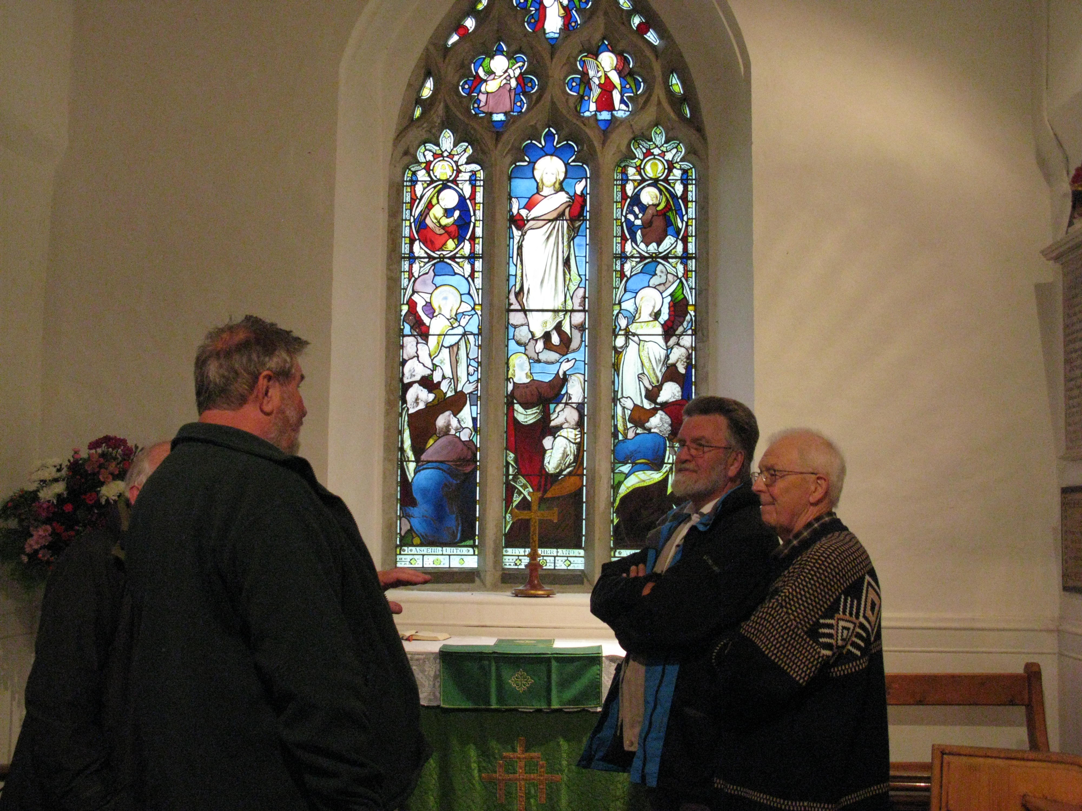
Members visiting Bramfield Church after the 2015 AGM

Barnet Enclosure Map
The two sets of maps of Hertfordshire published by the Society have proved very popular, and work on a third map is reaching its conclusion.

The map shows a small market town and a smaller village surrounded by open farmland and country estates, shortly before the dramatic effect of the introduction of the railways in the mid-nineteenth century. The Great Northern Railway cut the district in half, estates were sold off, land subdivided and the coaching traffic on which the town had thrived disappeared.

The map, and schedule that accompanies it, were the result of a private parliamentary Act of 1814-15 for 'inclosing lands in the Manor of Chipping (or High) Barnet and East Barnet, in the parish of Barnet. It carried an interesting rider: ‘no lease of lands, by the Rector of Barnet, without consent of His Majesty, his heirs and successors as patrons of the said rectory’. Notice was affixed on the principal doors of the parish church of East Barnet and on that of the chapel of Chipping Barnet, during divine service. It was further advertised in the County Chronicle. The enclosure award for Barnet is dated 1818.

The Enclosure Acts were to change the face of England and Wales for ever, seeing the final end in many areas of surviving remnants of the medieval open or three field system. A wave of enclosures took place between about 1755 and 1780, mainly in the English midlands and in some of the northern counties. The second tranche took place between the 1790s and the mid-1830s, peaking during the Napoleonic wars.

Enclosure in or near towns was done for different reasons to that in rural areas, being seen in some cases as a prelude towards the sale of land for later development, as well as a means of preserving open spaces (especially in London). By doing so, owners also effectively abolished the right of use of most common land for grazing, etc.

The use of enclosure awards and maps was well developed by the time the Barnet award was made, and their accuracy and authority makes them both of historical and social significance. Then, as today, they are sometimes used to settle ownership or boundary disputes by the courts. As with the Barnet example, map and schedule were often bound in book form, and after being made available for public inspection, were deposited amongst the parish records. The mapping was done by a competent Surveyor, appointed by the parliamentary commissioners, and a schedule produced in which the new ‘allotments’ (land awarded by the commissioners) were recorded. The area of the plot was never put on the map, only its reference number, and buildings were not mentioned as they were, for example, on the returns accompanying parish tithe maps a few years later. However, the built up areas, roads, etc. are all carefully plotted on the Barnet map with an accuracy that must have been the envy of the early Ordnance Survey cartographers.

The schedule lists a series of individually numbered plots, with the names of the owner(s) and/or tenant(s), the area of the allotment cited (in acres, roods and perches) and stating who was liable for the maintenance and upkeep of fences, walls, etc. - usually the new proprietors and their heirs or assigns. It will be seen from the Barnet schedule that some of the allotments were to organisations or institutions, including the University of Glasgow (704); Dutch Church, Austin Friars (721); Trustees of the Poor of Chipping Barnet (716); and the Governors of Poor Widows and Children of Clergymen (824).

This Barnet map and schedule are models of their kind, the like of which is rare in Hertfordshire terms. With additional historical notes and a name index, they will be of interest and value to those working in both local and in wider contexts.
Edited from text by the late David Dean

Feet of WHAT?
A future volume, being prepared by David Johnson and Philip Harrison, will be a calendar of Feet of Fines for the County of Hertford. Your first impression may be that it might relate to Fines as pecuniary punishments, but they are a class of documents with a fascinating history.

‘Fines’ record Final Concords – the outcome of legal cases held in the King’s court to record the conveyancing of land, although by the fourteenth century the cases were largely fictitious, the vendor and purchaser having agreed beforehand to use the process to obtain a binding record. These would be written out three times on a single piece of parchment – one copy would go to each of the two parties contesting the case, and the other – the Foot – was retained as an archival record of the ruling. The parchment would be cut in wavy or indented lines; as a result the three copies would fit together, but a forged document would stand out. Fines were written in Latin until 1733

This process was used for property transactions from the twelfth century to 1833, when the Fines and Recoveries Act brought an end to Fines and Common Recoveries – but those are a different story!
Peter Elliott

David Johnson has provided the following example:
Date: 1 December 1203 (morrow of St Andrew, fifth year of the reign of King John) at Westminster

Justices: Geoffrey Fitz Peter; Richard of Herierd; Eustace of Faucunberg; Godfrey de Insula; John of Guestling; Walter of Creeping; Osbert son of Hervei

Parties: Walter son of Germundus plaintiff, Geoffrey son of Germundus tenant

Subject of fine: Nine acres of land, with appurtenances, in Sawbridgeworth (Sabricteswrthe)

Details of plea: There was a plea between them in the court. Geoffrey recognised all the land, with appurtenances, to be the right of Walter.
For this recognition, fine and concord, Walter conceded to Geoffrey all the land, with its appurtenances, saving to Walter and his heirs one half acre of meadow (prati) which pertains to the nine acres. In exchange for this half acre, Walter gave to Geoffrey another half acre of meadow in the meadow called Hallingesunt next to (iuxta) the meadow of William Wealensis towards (versus) the west, to be held by Geoffrey and his heirs from Walter and his heirs, in perpetuity, as the nine acres of land, through the free service of 4s per annum (12d at Christmas, Easter and the feasts of St John the Baptist and St Michael) for all service except forinsec service.
For this concession, Geoffrey gave to Walter 20s sterling.

Ms: (TNA) CP 25/1/84/6 no. 82

Notes: The rolls of the royal court note that, in the Easter Term of 1203, Walter sought a view of the lands and that this was granted; a date was given for the case three weeks after Holy Trinity (see CRR ii 245). This entry also confirms that, as one might have guessed, the two men were brothers.

Life in Hertford Gaol for ‘a Hardened and Mischievous Lad’
This is how William Willson, the Governor of Hertford gaol, described John Scales, one of his young charges in April 1836. John had pulled nails from his cell window, breaking it in the process. John’s punishment was to spend three days in a solitary cell on bread and water. In June that same year Willson’s patience was tried again when he declared that John Dyer was one of the worst disposed boys he had ever had in the prison. John Dyer had done something which was bound to scandalise both the Governor and the chaplain. He had defaced the prison prayer books. For the act he was sentenced to two days in a solitary cell. This had little deterrent effect because two days later he was caught selling his, presumably, spare pair of underclothes to a fellow prisoner. He was again sentenced to detention in a solitary cell for three days. In October 1837 Robert Bush was put in a solitary cell for three days for ‘making use of the most blasphemous language’. Willson stated that Bush was one of the most depraved boys he had ever had under his care.

How do we know about what went on in the prison day to day and the governor’s feelings about his prisoners? It is because a Prison Consolidating Act of 1823 made the keeping of a journal by the governor compulsory. The journal was to detail the punishments meted out in prison for breaking the rules and ‘occurrences of importance within the prison’. The journals for Hertford Gaol from 1834 until 1878 have survived and are held by HALS. The first two volumes are being transcribed for the Record Society. They give a fascinating glimpse into life in the prison for staff and inmates.

What were the solitary cells like? They were small, completely dark rooms - all light being excluded except when the doors were opened to put in bread and water. In Hertford Gaol blinds were fitted on the outside of existing cells when more solitary cells were needed. The poets Coleridge and Southey jointly wrote a poem about the devil walking through London. He passed Cold Bath Fields Prison and saw a solitary cell. ‘The devil was pleased for it gave him a hint/for improving his prisons in hell.’ It says much for the resilience of teenage boys that John Scales and John Dyer could endure three days in such places several times without having their spirits broken. In 1835 a 13-year old lad, Thomas Robinson, was held in a solitary cell for three days for using ‘most blasphemous language’. We do not know what effect it had on him but he does not appear to have been held in a solitary cell again.

The 1830s and 1840s were an important period in prison history for many reasons. The prisons of the eighteenth century had been brutal places where men and women were herded together, often held in irons, and where gaolers got their remuneration by charging the prisoners fees. Prison was a place where people were held until trial. If found guilty, they could be fined or branded, whipped or transported or hanged. By the 1830s punishment usually took the form of a term of imprisonment, often with hard labour such as working on the treadmill. Men and women were kept separately and warders were paid a wage. Prisons were still unpleasant places but more orderly. Severe punishments for breaking prison rules were deemed necessary for keeping sentenced prisoners under control.

13-year-old Thomas Robinson was not the youngest person to be held in Hertford Gaol. The 1841 census shows that 16-month-old George Fuller was held in a cell with his mother Mary Fuller. Once weaned, he would be taken to the workhouse unless a friend or relative could be found to take care of him.
Eileen Wallace
Review of Volume 26 from the Newsletter of the St Albans & Hertfordshire Architectural & Archaeological Society
John Carrington was a prosperous resident and dutiful citizen in eighteenth century Hertfordshire – Lord Cowper’s tenant of Bacons in Bramfield near Hertford, where he was sometime churchwarden and overseer. He was also chief constable for the parishes in that part of the Liberty of St Albans and his community duties and business affairs brought him regularly to the Assizes, to meetings at the Town Hall and inns in St Albans. His jottings concerning these and other journeys, the business conducted and other personal activities provide a valuable insight into the life of his times in St Albans and Hertfordshire.

Publication of the long known ‘diary’ by the Record Society brings the information in it to a wider audience. Susan Flood’s introduction sets the scene, identifies individuals and places, and highlights significant areas of Interest.

Carrington was not a high status individual, but he was successful and prominent. Starting life as a servant to a local landowner, he became, in maturity, a substantial property owner with considerable responsibility for local administration, enjoying income from the various positions and the connections which brought him a varied and pleasant life.

He tells us of the weather, crops, and market prices as well as of people he encounters, including a variety of lodgers and visitors to the farm. His later life, when his sons could look after the farm, is full of interest. He rides to market in Hertford, to neighbouring parishes and towns on Liberty business, and sometimes to London on business or pleasure. He describes in detail a trip to Brighton on holiday. He travels usually on his own horses and ponies, but sometimes in his cart and also remarkable distances on foot. We hear of the routes he takes and where he stays and eats. His notes include costs, prices, and what he gives by way of donations and tips, and taxes he pays and collects.

Significant for St Albans researchers are his frequent journeys to the town. He stays and eats exclusively at the Red House, an inn centrally placed, at what we can now interpret as at the Chequer Street entrance to The Maltings. Run by a cousin, Thomas Piggott, it was a natural stopping place for Carrington. His contacts in the town revolve around the business for which he came – so his frequent contacts with attorney John Cowper may have led to articles for cousin Thomas Piggott’s son Isaac. Isaac Piggott subsequently became Town Clerk in St Albans.

The notes are arranged by date and were clearly intended only for Carrington’s own record, but they were subsequently bound together and so now form a diary. Separate from this volume is the ‘Arithmetic Book’. This was a workbook, maybe from his own schooldays. It has been used by family members for notes, both of a business nature and for more general observations. It is from this volume that we hear of the celebrations around
the coronation of King George III in 1761, well before the start of the ‘diary’ notes, which record his life only from 1798 to 1810, notably a period of both war and peace. This kind of social historical information is interesting, but also valuable to set other historical data in context. Some details will add something for individual researchers, but the picture of the life of an active person with social responsibilities has value of its own. The background details added by the introduction and copious footnotes make it easy to digest, although I did note the deliberate mistake, which reminds of the need for caution in using any material of this kind – the two boroughs in the county each had two representatives in Parliament rather than the one suggested in one of the notes.

The book is a valuable contribution to the early modern history of Hertfordshire and St Albans, and a good read for its insight into personal situations and the occasional extraordinary event. I enjoyed Carrington’s candour when, ‘fuddled’ after a night out, he fell off his pony – this is information not readily found in text books!
Kate Morris

Review of Volume 31 from the British Art Journal
The young Lord Fordwich is better known as the 3rd Earl Cowper, as he became, and for the portraits of him and his future wife by Johan Zoffany, notably in The Tribuna, where he appears in front of Raphael’s Cowper Madonna that Zoffany sold him. A major hoard of documents in the Hertfordshire and Local Studies archive (sic), the journal kept by Fordwich’s Swiss tutor Jean Chastellain, has now been transcribed and translated from French and Italian. The result of some formidable editing is an astonishing reconstruction of a Grand Tour in great detail, offering an entirely new understanding of this raffish character, who was one of the key inglesi Italianati in Florence.

Paying by bank transfer
It is now possible to pay your subscription, and/or for book purchases by bank transfer. If you choose to use this facility, please ensure that when making your payment, it is clear who has sent the payment and what it is for. Payments by bank transfer should be made to:
Bank: CafCash Ltd,
Kings' Hill, West Malling,
Kent, ME19 4JQ

Sort Code: 40-52-40

A/c name: Hertfordshire Record Society

Account Number: 00018349

If you need to inform us of a change of address, please put such information in an email to the Secretary at hfalvey1@btinternet.com

