Newsletter No 29 Spring 2015 Hertfordshire Record Society
Chairman: Dr Alan Thomson Secretary: Dr Heather Falvey Treasurer: Mr Ian Fisher

Chairman’s Report

The Trustees have met on 3 occasions since the AGM on 21 June 2104 at Weston School. We would like to thank Ellie Shaw, the head teacher, her staff and the parents’ association for organizing the event for us and providing some delicious refreshments. Following the AGM we were able to launch the publication of Volume 30, Weston School Log Books 1876-1914 and one of our trustees, Margaret Ashby, gave an entertaining introduction to the book which she and her team had worked on for a number of years. It was a most memorable occasion in a beautiful rural setting.

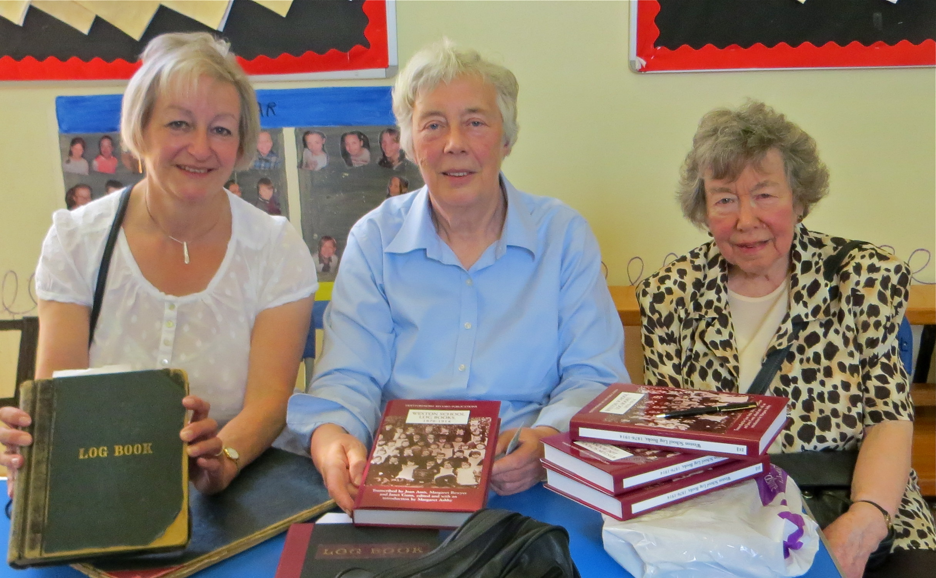
The launch of Weston School Log Books on 21 June at the school. Left to right, Janet Gunn, Margaret Ashby, and Joan Amis.
Photograph by Jean Archer

An important innovation this year has been the provision at the Trustees Meetings by Mr Gary Moyle, the representative from HALS, of a spreadsheet of recent accessions to the County Archives. Although, so far, we have not found any items that we could see being published in the near future by the Society, there are some fascinating primary sources that some of our members might like to study. These have included manorial records, such as those from Little Berkhamsted, 1620-1766, where the manor passed from the Weld to the Dimsdale family; title deeds for the manor of Rickmansworth, 1804-1851; and documents 1577-1875 relating to the manor of Cheshunt. More recent records include a collection of photos, postcards, match cards and cuttings for St Albans Football Club 1891-1911; and audio cassette recordings of a 100-year-old resident and others from Standon, who discussed farming, steam ploughs and the Buntingford railway branch line.

For members who are pursuing the history of their own parish or family, there are other accessions that may be of interest including title deeds relating to Ashwell and the Bluett family, 1648-1726; title deeds, probate and account books relating to Stevenage and the Smith family, 1636-1940; and Letchworth Fire Brigade records 1885-1987.

Hertfordshire Buildings Preservation Trust have also deposited over 600 items, including glass plates and negatives of Hertfordshire’s built heritage taken in the 1950s and ’60s, which are currently being digitized and will become available to HALS users. Over 40,000 images have already been scanned. Many other photos from a variety of sources have also been accessioned, including those from The Herts Advertiser 1920-29; postcards from Bushey, Great Gaddesden, Hatfield, Watford and St Albans from the 1900s; and post cards and images 1895-1977 deposited by Watford Central Library.

The Trustees have also been informed of book sales and stock by Jane Walker, who provides a spreadsheet of the current position, which helps us to decide which books to write down to a lower price. We have received some second-hand copies of our earliest publications, enabling us to make donations to The University of Hertfordshire and other organizations who were missing volumes in the series. It also means that we have a small stock of the out-of-print volumes, if members wish to make up their own set.

I would like to thank Heather Falvey for all her hard work over the year as Secretary, providing us with appropriate agendas, detailed minutes and details of correspondence and reviews; and Ian Fisher, our new Treasurer, who has kept us regularly informed of our current financial position.
Alan Thomson

Volume 26: John Carrington, farmer of Bramfield, his Diary, 1798-1810, volume 1, 1798-1804

The 2015 AGM will see the launch of Volume 26, originally scheduled for publication in 2010/11.

John Carrington, farmer, overseer, tax collector and local constable of Bramfield, Hertfordshire, was born in 1726. Following in his father’s footsteps at the age of 20 he became gardener to Lady Cathcart at Tewin Water House. By the 1750s he was employed by Richard Warren of Marden Hill, Tewin and in 1760 became his master’s tenant of Bacons Farm, Bramfield. An educated man, his earliest jottings, dating from 1738, are added to a book containing instructions ‘to Add several sums into one Total summe’ alongside arithmetical calculations which show that the young John had learned his lessons. The variety of subjects he chose to write about paint a picture of the man he was to become in later life: memories of storms, floods and fires, political and historical notes, and local news and gossip to a recipe for rheumatism and a cure for lice in cattle.

Shortly after the death of his wife in 1798, when John was 72, he began to keep a diary, and continued it until
12 days before his own death in 1810. John wrote for his own amusement and perhaps to interest his own family. He wrote on anything that came to hand: the backs of sale particulars, accounts, bills, official printed instructions for the public duties he performed, assize calendars, and Navy Lists, which were later roughly bound together into thirteen volumes now held at Hertfordshire Archives and Local Studies. These form an almost daily record of the last 12 years of his life, years which saw great change and often hardship for local communities caught up in the effects of the Napoleonic wars.

Volume 26 is the long awaited first part of a full transcript of the diary of John Carrington of Bramfield. In 1956 an abridged version of the diary was edited by William Branch Johnson and published as The Carrington Diary (1797-1810). This sold out and was republished in 1969 by Hertfordshire Countryside as The Hertfordshire Pepys: John Carrington of Bramfield and his diary from 1797 to 1810. This also sold out and in 1973 Branch Johnson’s edition was republished again, this time by Phillimore, as ‘Memorandoms for –’: the diary between 1798 and 1810 of John Carrington, farmer, Chief Constable, Tax Assessor, Surveyor of Highways and Overseer of the Poor, of Bramfield in Hertfordshire. This third edition has also long been out of print. Branch Johnson’s excellent book was obviously popular but it omitted diary entries that did not refer directly to Hertfordshire and both his weather recollections and occasional jottings, obituaries and personal notes on villagers. The whole text of the diary from 1798-1804 is included in this edition by the HRS together with much earlier entries jotted down in a volume the family termed ‘The Arithmetic Book’. This will more fully demonstrate Carrington’s life and interests outside of his chosen profession. In addition the volume will be accompanied by an historical Introduction, appendices to include biographies of local persons frequently mentioned by Carrington, a glossary and full indexes of names, places and subjects.

A further volume will include the second part of John’s diary from 1805 to 1810 and the diary of John’s son Jack who continued his father’s diary until 1812, together with some earlier jottings. This publication will make John’s life fully accessible to all.

As this is the volume for 2010/11 members who joined after April 2011 will not automatically receive a copy, but they can purchase it at the member's price of £17.50.

Forthcoming Volume:
Lord Fordwich’s Grand Tour, 1757-1760, HRS Volume 31, to be published in November 2015.

In January 1757 George Nassau Clavering-Cowper left England to undertake his Grand Tour of Europe. Styled Viscount Fordwich, he was 18 years old and heir to an earldom.

At that time there was a good deal of debate amongst the English aristocracy as to the benefits and drawbacks of the Grand Tour. On the one hand, it was felt that the experience of foreign travel helped a young gentleman to develop his intellectual and artistic tastes; give him the opportunity to learn about methods of government in other countries; develop his fluency in foreign languages; and help give him social poise and confidence. These would all be of immense advantage when he came into his inheritance and took his place amongst the ruling class of English society. It was well appreciated, however, that such lofty ideals were not always attained.

Many young gentlemen found the whole experience a crushing bore, while others picked up objectionable ‘foreign’ habits and were led astray by loose women. In fact, some commentators considered that, on balance, the experience of European travel did more harm than good, particularly in Italy where the moral hazards were especially difficult to avoid.

In most cases a young gentleman would be away on his Grand Tour for about a year, but in the case of Lord Fordwich, the experience was to last three years. The first two years were spent at the renowned Academy in Lausanne. Then in April 1759 he set out on a trip which took him through the Rhineland, Bavaria and Austria, then south to Italy. By June he had arrived in Venice, from where he travelled on to Padua, Bologna, Florence, Lucca, Pisa, and Siena. He then spent a month in Naples and another six weeks in Rome. During this time he responded very positively to the experience; indeed, his tour of the Italian cities awakened what was to be a life-long interest in art and music. Unfortunately, he also proved highly susceptible to the moral hazards of the Grand Tour, for while in Florence he fell passionately in love with a beautiful Florentine lady known as the Marchesa Corsi. The tour was due to finish in December 1759, whereupon he would depart from Rome and head back to England. Young George, however, was in the unusual position of having the means and freedom to indulge his desires, and so he headed back to Florence. His passion for the lady eventually burnt itself out, but by then he was thoroughly embedded in the cultural and social life of Florence, and kept on postponing his return to England.

The circumstances surrounding the Grand Tour of the future 3rd Earl Cowper were rather unusual in that the tour was funded not by his father, but by a legacy granted to him by his maternal grandfather, Henry de Nassau, 1st Earl of Grantham (1673-1754). Under the terms of his grandfather’s will George was to receive an initial sum of £1,600, plus a further sum of £475 ‘for his use, as the executors think fit, for travels, his maintenance, education and improvement.’ Furthermore, in a codicil to his will, Earl Grantham left very specific instructions as to how matters were to be handled until George came of age. Since he was only 16, George would not have full control of his inheritance for another five years, but it was nonetheless an extremely generous settlement to bestow upon a teenage boy.

Earl Grantham also appointed the man who was to be George’s Governor during his travels. His name was Jean Chastellain (1716-72). He was of Swiss nationality and came from Vevey, a small town on the north shore of Lake Geneva, about ten miles to the east of Lausanne. The arrangements for the tour were finalised towards the end of 1756, by which time George was 18 and Chastellain 40 years of age. The tour party also included two attendants, Pierre Louis Jordan and Christofle Trissel.

George attained his majority on 26 August 1759 while staying in Florence, at which point he assumed full control over his maternal grandfather’s legacy. This represented a substantial fortune over which his father had no control whatsoever. George was thus in a position to indulge his desires and prolong his stay in Florence for an indefinite period, while his family could only appeal to his better nature and make him aware of his filial duties. Their efforts proved in vain and the 2nd Earl Cowper died in September 1764 without ever having seen his son return home. On succeeding to the Earldom, George became a man of truly staggering wealth for, in addition to his grandfather’s legacy, he now inherited land and property in London, Hertfordshire, Kent, Yorkshire and County Durham. All this meant that he was freer than ever to follow his desires and make Florence his permanent home. Apart from one short visit to England in 1786, he remained in Florence until his death in 1789.

Lord Fordwich’s Grand Tour is based primarily on research carried out over the past five years by a group of people, most of whom are members of the Hertford and Ware Local History Society. Between them they have investigated various documents relating to the 3rd Earl Cowper. These documents are contained within the Panshanger archives, which are housed at the Hertfordshire Archives and Local Studies (HALS).

There are two major sources of information about the Grand Tour. Firstly, there is a journal of the tour which was compiled by Jean Chastellain (DE/P/F308). It covers the whole tour from January 1757-May 1760 and comprises some 96,000 words. Secondly, there is a set of detailed financial records, again compiled by Chastellain, which also covers the entire period of the tour (DE/P/AF239). Chastellain’s journal makes no mention of George’s tempestuous affair with the Marchesa Corsi. However, these matters were dealt with in some correspondence between Chastellain and the 2nd Earl Cowper. These letters have also been investigated, therefore, together with later correspondence between George and members of the Chastellain family. The journal, financial records and correspondence were all written in French, and the task of transcribing, translating and editing this material has been undertaken by Sheila White and Philip Sheail.

Appendices will include biographical sketches of the most notable contemporary and historical figures mentioned in the diary. Together with a detailed Introduction, full Indexes, Bibliography and Glossary this will be a highly fascinating volume.
Philip Sheail
Review of Volume 30 in The Local Historian, 45 (January 2015), pp.77-8

Whilst surviving school log books are extremely numerous from the 19th century, it is rare to see that for a single school transcribed as a key volume of a county record society. Weston is a village between Baldock and Stevenage and Hertfordshire Record Society has transcribed three of the surviving log books the last truncated at 1914 as a result of the 100-year rule.

As with many log books, the detail depended on the assiduity of the particular compiler, usually the headteacher, as does the issues of personal concern. The log books cover a period long enough to see several changes of style with occasional glimpses of the wider world such as special lessons on the Boer War and the death of Edward VII.

This is not a criticism but what stands out from these log book entries is how typical the school was and the events associated with it. This was a fairly small rural school which grew to around 150-180 pupils. The challenges faced by this school were similar to countless others throughout the land. Attendance was a major concern of the headteacher and the managers. Most pages have some detail about attendance but it does vary and seems much improved in later years. Many illnesses were mentioned – so many that a separate appendix is added. Few though seem life threatening and frequently the absences were the result of the needs of the farming economy.

The entries reveal changes to education in this community as well as much continuity. The earlier entries focus largely on attendance and standards (particular the HMI visits) although the laconic ‘Weston School totally destroyed by fire’ (14 January 1883) indicates that there are wider concerns. Later entries contain much more on the curriculum. The earlier entries also reveal a lack of respect amongst many families for education. The headteacher’s claim in 1894 that ‘most of the parents are anxious that their children shall not remain in school one day longer than is necessary’ is followed soon by another that ‘Stevenage Magistrates are of the opinion that no child who lives more than 2 miles from a school can be compelled to attend’ and ‘parents are obstinately opposed to home lessons’.

Later entries reveal other changes. The influence of the County Council in the 20th century with visits, instruction, circulars such as that on teaching needlework and prizes seems benign and generally to have been welcomed by the school. Inspectors report on variable standards throughout the years but are rarely damning. In later years the school seems to have gained a reputation for gardening.

Log books are fascinating documents especially when the compilers go beyond basic facts and figures to give opinions and vent their frustrations. The school is closely linked to its community and there are fairly frequent treats provided such as buns, biscuits and cocoa. The school receives many visitors and the Church keeps a watchful eye. This is not a school characterised by the excessive use of the cane and many of the teachers, pupil teachers and monitoresses are clearly dedicated and committed. Conditions are far from good though with the playground not fit for use in muddy weather and there are hints that the teaching was very didactic.

This is a welcome addition to the growing body of educational history. Its useful introduction and the carefully compiled entries over a sizeable number of years provide us with an insight into a community which allows intimate glimpses into issues extending way beyond the classroom walls.
Tim Lomas

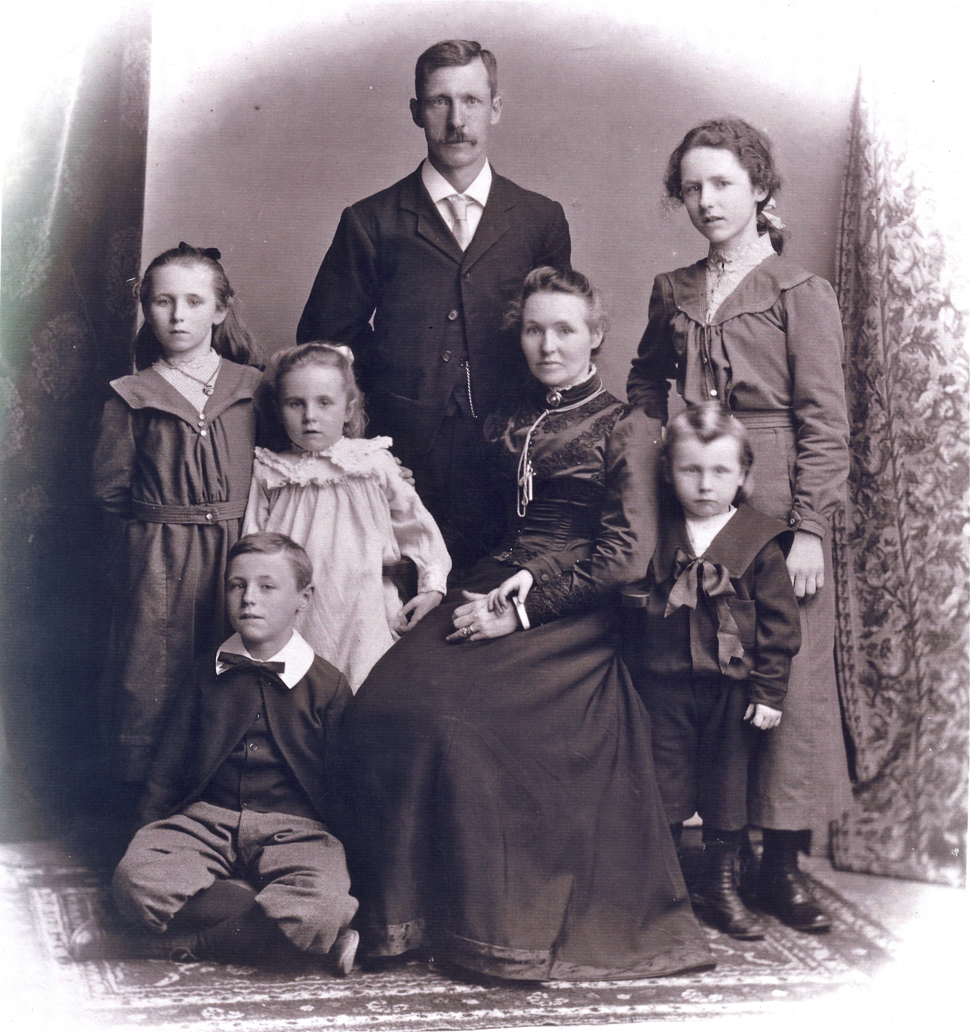
Weston School headmaster Alfred Harrison Bradbeer with his wife and family

Dow Nuts
In last year’s newsletter Heather Falvey wrote about the media interest generated by the recipe for ‘Dow Nuts’ in Baroness Dimsdale’s recipe book. Michael Krondl, a food historian in America, has provided a modern version of the recipe, for those members who might wish to sample these Hertfordshire delicacies.

Because of the high butter content this recipe takes a relatively long time to rise. To help matters along, keep the bowl in a warm location. Lard really is ideal as a cooking fat but vegetable shortening will work. Oil tends to make the nuts taste greasier. Though the recipe doesn’t call for it, I like tossing the nuts in granulate sugar once they’ve cooled a little. It’s unclear how these were served. An earlier recipe for Hertfordshire Nuts mentions they can be given to farmers’ servants for dinner but that version is decidedly less rich than this one. In the nineteenth century, they were traditional for Shrove Tuesday. Given the dining fashion in the baroness’ day it is plausible these were a sort of ‘entremet’ – fritters of various kinds are often described this way – that is plate set between other dishes on the table, a side-dish if you will.
This version yields half of the original recipe, or about 4 dozen ‘nuts’.

¼ cup lukewarm (110°F) water
1 envelope (1/4 oz) active dry yeast
½ pound (1 cup) raw sugar
1 imperial quart (i.e. 40 fl. oz. or 5 cups) unbleached all-purpose flour
½ whole nutmeg (a teaspoon or so), grated
4 large eggs, lightly beaten, at room temperature
2/3 cup milk at room temperature
6 ounces unsalted butter, melted and cooled
Lard or vegetable shortening for frying

1. In a small bowl, 1 teaspoon of the sugar into the lukewarm water, stir in the yeast. Set aside until foamy, about 5 minutes.

2. In the meantime, sift together the flour, remaining sugar and nutmeg.

3. Transfer the yeast mixture to the bowl of a stand mixer fitted with a paddle attachment. On medium-low speed, beat in the eggs, milk then about half the flour mixture. Beat in the butter. Switch to a dough hook attachment, gradually add the remaining flour. Beat on medium-low speed until the dough is smooth, shiny and elastic. It will still be a little sticky. About 5 minutes.

4. Remove the dough from the bowl and set on a floured surface. Knead very briefly to turn it into a ball. Set in a buttered bowl, cover with plastic wrap and let rise in a warm place until doubled in volume, about 2 hrs.

5. On a floured surface roll the dough about ¼-inch thick and using a pastry wheel cut it into 1 ½ inch squares.

6. Brush these lightly with melted lard on each side. Set on a baking sheet lined with parchment and cover loosely with plastic wrap. Let rise until they are about 50% larger (about ½ hour).

7. Heat at least 2 inches of lard or vegetable shortening in a deep pan to 350°F. Slide the dow nuts in one by one making sure not to crowd the pan. Stir and turn regularly until golden brown, 1 to 2 minutes. With a slotted spoon, lift out the cooked nuts and drain on a cooling rack set above a baking pan or on paper towels. Serve warm.

Paying by bank transfer
It is now possible to pay your subscription, and/or for book purchases by bank transfer. If you choose to use this facility, please ensure that when making your payment, it is clear who has sent the payment and what it is for. Payments by bank transfer should be made to:
Bank: CafCash Ltd,
Kings’ Hill, West Malling,
Kent, ME19 4JQ

Sort Code: 40-52-40
A/c name: Hertfordshire Record Society
Account Number: 00018349
If you need to inform us of a change of address, please put such information in an email to the Secretary at hfalvey1@btinternet.com

